Abstract template for talks and/or posters of the 25th International Conference on Spectral Line Shapes
Fasci E.¹, Moretti L.¹, De Rosa M.², Galzerano G.³, Gianfrani L.¹, Maddaloni P.², Castrillo A.†¹
¹Department of Mathematics and Physics, Università della Campania, Caserta, Italy
²National Research Council - Institute of Optics, Pozzuoli, Italy
³Polytechnic of Milan, Milano, Italy
†antonio.castrillo@unicampania.it

Abstracts must be submitted by sending an email to the Conference organizers (icsls2022@unicampania.it) using this template.
Figures of 300-dpi resolution can be included (see Fig.1, for example). Color figures will be converted to grey scale in the printed Book of Abstracts. Therefore, please verify that all figures continue to be easily readable. If you wish to include figures, do not forget to send us also the graphics source files (jpg format is preferred).

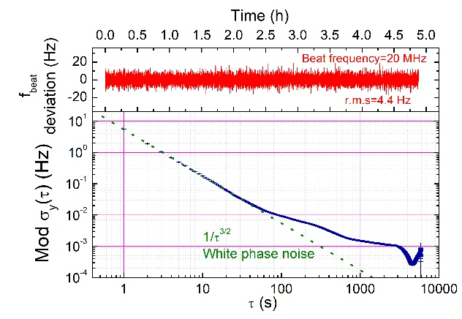
Figure 1: Example of figure.

Equations should be written using Word Equation Editor. Equation 1 is an example:

$\int_{x_{a}}^{x_{b}}{\frac{1}{x}dx}=\ln{x_{b}}-\ln{x_{a}}=\ln\left(\frac{x_{b}}{x_{a}}\right)$. (1)

References can also be included as footnotes. If the authors are more than six, references must be cited according to. If necessary, a table can be inserted following the example of Table 1 reported hereafter.

Table 1: Table caption here
Contribution | Type A  (ppm) | Type B  (ppm)
Reproducibility | 22÷23
Frequency scale |  | <2
Line center frequency |  | <10⁻⁴
Overall combined uncertainty | 23÷24

A. Castrillo, L. Moretti, E. Fasci, G. Galzerano, M. De Rosa, and L. Gianfrani, Journal Name Volume, first page (year).
A. Castrillo et al., Journal Name Volume, first page (year).

